**Appendix D**

**Expression of Interest for**

**Development of Eco-tourism Nodes in Tsim Bei Tsui and Pak Nai**

**(REPLY FORM)**

This Reply Form should be duly completed with two copies deposited in the **Development Bureau (Works Branch) – Contractors’ Drop-in Box (Professional Services Unit) labelled “Expression of Interest for Tsim Bei Tsui and Pak Nai, ex-Lamma Quarry and South Lantau Eco-recreation Corridor Drop-in Box”** at 2/F Entrance, East Wing, Central Government Offices, 2 Tim Mei Avenue, Tamar, Hong Kong on or before 12:00 noon on 2 July 2025 (Wednesday). You are encouraged to include a proposal with supporting information including but not limited to drawings, plans and explanatory statements along with your submission.

1. Information of the Interested Party
2. Company Name

|  |  |
| --- | --- |
| (In English): |  |
| (In Chinese): |  |

1. Name and Post Title of Contact Person

|  |
| --- |
|  |

1. Contact Phone No.

|  |
| --- |
|  |

1. Contact Email

|  |
| --- |
|  |

1. Background of the Interested Party
2. Core Business

|  |
| --- |
|  |

1. Details of similar projects that your company developed and/or operated (either planned or already implemented) in Hong Kong, Mainland China or overseas.

|  |
| --- |
|  |

1. Submission of Views

**Development Plan**

1. Do you have an interest in developing, financing and operating whole or part(s) of the Tsim Bei Tsui and Pak Nai Eco-tourism Nodes? Please select the area(s) below you are interested in (you can choose more than one).

( ) whole of Tsim Bei Tsui Eco-tourism Node (a total of 55 ha)

( ) part(s) of Tsim Bei Tsui Eco-tourism Node (about _____ ha out of 55 ha)

( ) whole of Pak Nai Eco-tourism Node (a total of 22 ha)

( ) part(s) of Pak Nai Eco-tourism Node (about _____ ha out of 22 ha)

1. Please indicate on the plan provided below (i) the broad area(s) within the two Eco-tourism Nodes you have interest to develop based on your selection(s) for Question 7, and (ii) the location(s) and GFA for each Item of proposed land uses you select in Question 9. In doing so, you should make reference to Government’s preliminary land use proposals in **Appendix C** but you may suggest changes to those proposals if you consider necessary. You may assist your presentation showing your preliminary design concepts, site layouts, etc. for tourism-related uses (ERF, RH and RDE) and OCU with additional plans or other form of rendering as you see fit. Please also note the following requirements while filling information on the plan:
2. The total GFA allocation to tourism-related uses (i.e. Items A to D in Question 9) should be not less than 40% of the total GFA for Tsim Bei Tsui and not less than 50% of that for Pak Nai. The Interested Party is expected to cover at least Items A to C in the tourism-related uses which together should create a self-sufficient eco-tourism node providing curated and unique experiences and catering to diverse requirements, from retail and dining, to leisure and accommodation. The Interested Party is free to propose the split of total land area and GFA for tourism-related uses amongst Items A to D.
3. Eco-tourism and Recreation Facilities (Item A) are intended to serve the need of outdoor activities such as mountain biking, hobby farming, fishing, glamping/camping, etc. supported by ancillary indoor facilities. They are assumed to be subject to a plot ratio of about 0.2. Therefore, each square metre of the GFA allocations will imply also a land area allocation of 5m2 of land area.
4. Resorts/Hotels/Wellness Centres (Item B) and Retail, Dining and Entertainment (Item C) are uses intended to be low-density development for mainly indoor activities as the name suggested. They are assumed to be subject to a plot ratio of no more than 1.5. Therefore, each square metre of the GFA allocations will imply a land area allocation of no less than 0.67m2 of land area.
5. For the Other Required Facilities in each of the area you choose to develop, you are expected to at least –

(i) base on the standards and requirements set out by the Government, clear and form the site(s) for roads/pedestrian streets, construct the roads/pedestrian streets and their associated underground infrastructure required, and hand the site(s) with the roads/pedestrian streets and underground infrastructure completed to the Government;

(ii) base on the standards and requirements set out by the Government, clear and form the site(s) for GIC facilities, and hand the formed site(s) to the Government; and

(iii) base on the standards and requirements set out by the Government, clear and form the site(s) for open space, construct the open space(s) required according to the designs proposed by the developer(s) and agreed by the Government, and hand the site(s) with open space(s) over to the Government.

1. The amount of each kind of Other Required Facilities you need to take up can be estimated on a pro rata basis based on the amounts of Other Required Facilities specified in Table 1 under paragraph 31 for Tsim Bei Tsui and in Table 2 under paragraph 33 for Pak Nai. For illustration purpose, if you are taking up half of the 55 ha for the Tsim Bei Tsui Eco-tourism Node, you will then be responsible for half of the Other Required Facilities, meaning about 3 ha of GIC sites, about 2.5 ha for open space and about 10.5 ha for roads/pedestrian streets.

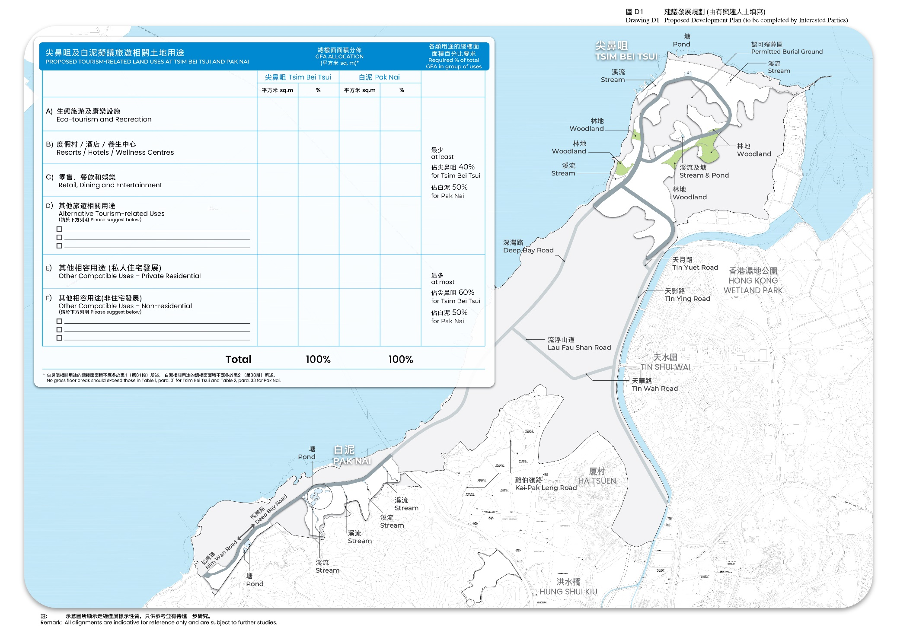

1. For the proposed land uses chosen above, please specify your preliminarily intended facilities/activities under each category:

A) Eco-tourism and Recreation Facilities

*A1 Scenic Activities*

* A1a Eco-Tours (e.g., bird watching, mangroves site seeing, etc)
* A1b Boat Tours / Recreational Fishing
* A1c Educational Workshops
* A1d Recreational Farming / Fishing / Eco-farms
* A1e Oyster Experience and Tasting
* A1f Others (please specify): ________________________

*A2 Adventure-based activities*

* A2a Hiking Trails
* A2b Eco-lodges / Glamping / Camping
* A2c Eco-adventure Park
* A2d Others (please specify): ________________________

B) Resorts / Hotels / Wellness Centres

* C1 Mid-range Hotels
* C2 Branded High-end Resorts / Hotels
* C3 Health and Wellness Resort (please circle as appropriate): with / without medical facilities
* C4 Others (please specify): ________________________

C) Retail, Dining and Entertainment

* B1 Retail Mall / Outlet
* B2 M.I.C.E. complex
* B3 Others (please specify): ________________________

D) Other Tourism Uses (please specify)

* D1______________________
* D2______________________
* D3______________________

E) Other Compatible Uses - Private Residential

* E1 Low-to-medium Rise Apartments
* E2 Villa/Semi-detached Houses
* E3 Branded Residences (linked to High-end Resorts / Hotels)
* E4 Other (please specify): ________________________

F) Other Compatible Uses – Non-Residential (please specify)

* F1 ______________________
* F2 ______________________
* F3 ______________________

1. Do you think the Lau Fau Shan Seafood Market would have synergy with your development proposal? If yes, in what ways and do you have interest in also taking up the preservation and in-situ improvement initiatives for the Market mentioned in Footnote 3 of the main contents of this document as part of your proposal?
2. Do you think the open spaces you are required to construct would have synergy with your development proposal? If yes, in what ways and do you have interest in also taking up the management and maintenance of these open spaces?
3. Please share your views on the development schedule and the pre-conditions for the development of the two proposed Eco-tourism Nodes:
4. When do you find appropriate for the Eco-tourism Nodes to be developed and commissioned with respect to the availability of government-led infrastructure as suggested in paragraphs 19 to 21 of the main contents of this document?
5. Should the two Eco-tourism Nodes be developed concurrently, or one of them should be developed first, and which one?

1. What government-led infrastructure (such as those covered in paragraphs 19 to 21 of the main contents of this document) you find essential to facilitate the development of the two Eco-tourism Nodes? (Please be specific and only include those essentially done by the Government)

**Details of Proposed Land Uses**

Based on your selections in Questions 7 to 12, please provide details about your business plan (e.g. type of facilities, brands to be introduced, operational model, development/construction duration, etc) for each of your proposed land uses in the area(s) you choose to develop.

1. How will you phase the development? Please advise the intended number of development phases, when will each phase start and end, and proposed land uses covered in each phase.
2. For eco-tourism land uses:
3. What business models would you propose for the development and operation of the proposed eco-tourism land uses? Will you design, build, finance and operate the facilities all by yourself? Or will you partner with other investors or market players and if yes what are your and their roles in the development? Please provide potential revenue streams (e.g. hotel room charges, ticket sales, activity charges, memberships, food and beverage income) and proposed tariffs.
4. Based on your proposed business model, what types of operational costs do you anticipate? Please consider factors such as staff costs, maintenance, marketing, etc. How the types of eco-tourism activities may affect these costs? Please provide a breakdown if possible.
5. In terms of potential market demand, what is your projected visitor volume? Please provide an estimated breakdown of visitors by type (such as same-day visitors versus overnight visitors; local, Mainland versus overseas visitors, etc) where possible.
6. For retail, dining and entertainment (RDE) facilities, please suggest themes/features that may differentiate it from other RDE venues in Hong Kong and other cities of the Greater Bay Area.
7. For resort/hotel development and glamping/camping facilities, please suggest the optimal scale in terms of number of rooms, average room size, occupancy rate and potential linkage/interdependence with the eco-tourism land uses.
8. For any private residential development proposed as other compatible use, please suggest the optimal scale in terms of average unit sizes, the number of residential units and pre-sale schedule.
9. If you have any suggestions on other facilities, attractions, or activities to be included in area(s) you choose to develop under Item D and/or Item F of Question 9, please outline their contents, proposed site requirements and optimal scales.
10. What major challenges do you anticipate in taking forward your development proposal (e.g. infrastructure availability, transport connectivity, etc)? How do you propose to overcome these challenges?
11. In addition to the responses provided above, please specify any other key components or aspects that may be useful to the Government’s consideration. This may include but not limited to investment and financial projections, unit rates and assumptions, and innovative features.

**Procurement and Financial Considerations**

1. What is the estimated capital cost of investment (in HKD) to develop the land uses you select in Question 9 above?
2. Under the conventional tender approach, the Government may commence the tendering process for one or both of the Eco-tourism Nodes in early 2028 after completion of the statutory rezoning process. What are your views on this conventional tender approach and the proposed timeline? Also, what are your views on some possible form of conditional tender award before completion of the statutory rezoning process to facilitate early preparation of developer(s)?
3. What will be the expected return on investment (e.g. project internal rate of return, payback period, and/or other relevant financial indicators) to be generated for the Project to arouse your interest in undertaking the development proposal you suggest?
4. Alternative tender mechanisms:
   1. What are your views on adopting alternative tender mechanisms such as a two-envelope tendering arrangement taking into account non-premium factors in addition to premium offers as compared to traditional cash tender arrangement?
   2. What is your view on allowing successful tenderer to make premium payment through alternative arrangements such as payment by instalments with interest charged on a certain percentage, or a revenue- or profit-sharing arrangement with lower upfront payment? For payment by instalments, what is your comment on the interest rate (e.g. should a fixed rate or variable market rate be adopted?) and the number of years of instalments for the payment? For revenue- or profit-sharing mechanism, what will be the appropriate level of upfront payment, as well as ratio, timing and duration of revenue- or profit-sharing?
   3. Any other feasible financial arrangement(s)?
5. Please rate your willingness to perform and finance the following types of works for Other Required Facilities, from most willing (3) to least willing (1). Please enter (0) if you are absolutely unwilling to take up the said public work. Please also state the maximum capital cost that you would accept in each category. You may alternatively provide a grand total.

|  |  |  |
| --- | --- | --- |
| **Types of Works for Other Required Facilities** | **Rating** | **Acceptable Capital Cost (HKD)** |
| Site formation of adjacent open spaces and GIC facilities within the Eco-tourism Node |  |  |
| Superstructure of adjacent open spaces within the Eco-tourism Node |  |  |
| Road infrastructure within the Eco-tourism Nodes |  |  |
|  | Total  |  |

1. What would be your key considerations for your responses to Question 25 above (e.g. cost implications, technical challenges, risk-sharing, timeline (advancement or delay), or collaboration with the Government)?
2. Do you have any views on separate building covenant periods for tourism-related uses (ERF, RH and RDE) and OCU, as well as the proposed requirement that ERF, RH and RDE should be completed no later than OCU?
3. Do you have any views on the duration of the land lease? Should it be the normal 50 years?
4. What are your views on potential disposal and/or handover arrangements for the non-residential developments within the two Eco-tourism Nodes (including ERF, RH and RDE) either during or at the end of the land lease period (e.g. long-term investment, en bloc sale, potential sale to third party without restriction, etc), subject to the restrictions on alienation as suggested in paragraph 40 of the main contents of this document and having regard to Government’s intention of upkeeping the proper management and operation of the tourism-related uses in the longer term? For example, whether the successful bidder or its successor should be required to keep the tourism-related uses under its management and operation for a certain period before the tourism-related uses are allowed to be sold to third party, in full or in part? Please provide details on your preferred approach and any considerations that could enhance the feasibility or attractiveness of these arrangements.
5. Please describe any possible risks and constraints you believe may arise in the implementation of this Project (e.g. building constraints, planning issues, implementation phasing, etc). Please also suggest possible ways to tackle these risks and constraints.

**Others**

1. Do you agree with the suggested theme for two Eco-tourism Nodes as stated on paragraphs 31 to 34 of the main contents of this document? Why or why not?
2. Based on your experiences if any in operating/planning/developing eco-tourism within or outside Hong Kong, what innovative eco-tourism features and offerings can be introduced for the two Eco-tourism Nodes?
3. To develop eco-tourism as a premier tourism offering for Hong Kong, what types of Government support do you find necessary for the smooth operation and effective management of the two Eco-tourism Nodes (e.g. additional infrastructure supply, monitoring and evaluation mechanism, economic incentives)?

1. Please share your ideas on positive and proactive means to respond to the following site context (Please refer to **Appendix B** for their exact locations) and to create synergy between the Eco-tourism Nodes and other attractions in the LFS Area:
2. Urban-rural integration between local villages and the proposed tourism developments in terms of the ambience and synergy in functions (such as arranging visits to oyster farms and villages, promoting village culture, running eco-lodges by or in cooperation with local villagers, hiring the villagers as tour guides, etc).
3. Making use of the current attractions and activities along the Deep Bay coastline, together with the proposed Coastal Protection Park.
4. Making use of the terrain and local attractions in the LFS Area to promote hiking and bicycle tourism.
5. Other relevant components in the Broad Land Use Concept Plan as shown in **Appendix A**.
6. Some existing informal settlement clusters in Tsim Bei Tsui and Pak Nai possess a rural ambience and play a role in the existing oyster farming and fishery activities in the area. Do you think these informal settlements and their economic activities may synergise with the tourism development you propose and, if yes, how?
7. Apart from the above, do you have any other suggestions/comments on this Project?
8. Opt-out for disclosure of identity (Optional)

( ) We do not agree to disclosing our name and views provided in our EOI submission to the public. However, we understand our views would be used for collective analysis by the Government and as such they may form part of the results of the analysis which may be disclosed to the public.

**\*\*\* END \*\*\***

**Acknowledgement**

We understand that the invitation is not a pre-qualification exercise to shortlist or pre-qualify any application. Interested parties who do not submit an EOI will not be barred from taking part, or prejudiced against, in the forthcoming tender exercise. We agree that all information provided in the EOI invitation document is for reference only. We acknowledge that nothing in the EOI invitation document shall constitute a warranty, statement or representation, expressed, implied or imputed, by the Government as to the accuracy, reliability, completeness or usefulness of the information contained therein. We understand that the Government does not accept liability to any person howsoever caused by the use of or reliance on the information provided in the EOI invitation document. We understand that the Government reserves the right, without prior consultation or notice, to change the content of this EOI invitation document.

Authorised Signature :

Name of Authorised Person :

Post :

Company :

Company Chop :

Address :

Telephone :

Facsimile :

Email :

Date :